**Q1) Simplify the following Boolean expressions using Boolean Algebra**

* AB+AB’



* (A+B)(A+B’)



* ABC+A’B+ABC’



* ((w’+x’)y+z)’+wxz



**Q2) Canonical forms**



* write the Boolean expression f(x,y,z) = x’y+z’y in canonical sum of product (SOP) form



**Q3) Proof that NAND gate is a universal gate**



**Q4) Using K-map, simplify the followings to SOP and POS for each given K-map below:**



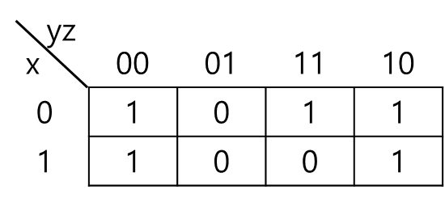



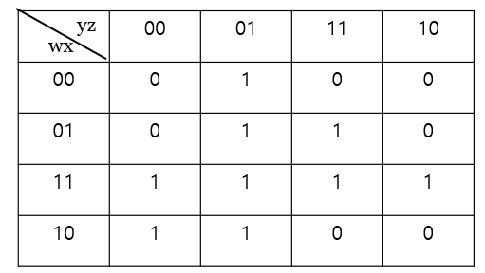



**Q5) Decoders**

* Design 4x16 decoder using decoder trees of 2x4



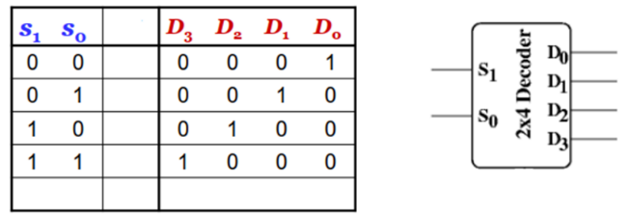



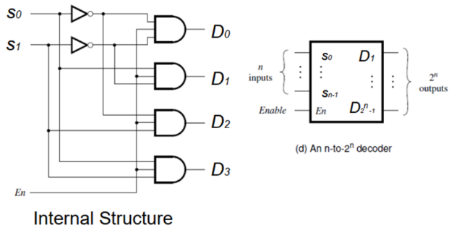



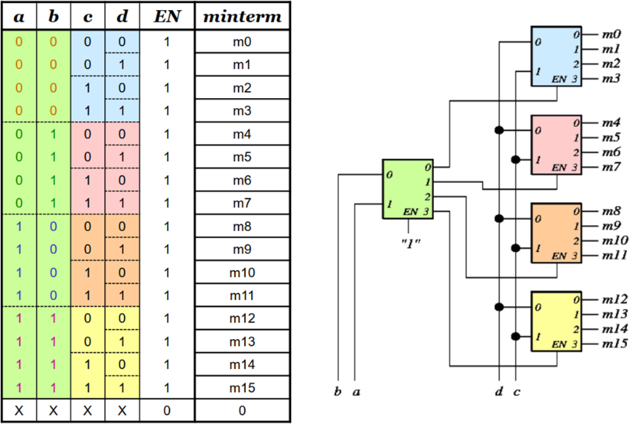



* Implement the logic of the following truth table using decoder



|  |  |  |  |
| --- | --- | --- | --- |
| X | Y | F1 | F2 |
| 0 | 0 | 0 | 1 |
| 0 | 1 | 1 | 1 |
| 1 | 0 | 1 | 1 |
| 1 | 1 | 0 | 0 |

